Name___________________
Introduction to Film

Unit 3: Teen Movies – The Perks of Being a Wallflower
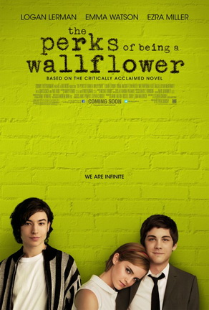
The Perks of Being a Wallflower is a 2012 American coming-of-age comedy-drama and is a film adaptation of the 1999 epistolary (written in letter form) novel of the same name. The film was directed by the author of the novel, Stephen Chbosky. Filmed in Pittsburgh, Pennsylvania, the film was released on September 21, 2012 to positive critical response and commercial success earning $33 million worldwide. The film stars Logan Lerman, Emma Watson and Ezra Miller. This is one of the three films from John Malkovich, Lianne Halfon and Russell Smith's Mr. Mudd Productions that feature struggling teenagers; the other two are Ghost World and Juno (Wikipedia.com).

Cast
Logan Lerman - Charlie
- Emma Watson - Sam
- Ezra Miller - Patrick
- Mae Whitman - Mary Elizabeth
- Kate Walsh - Mother
- Dylan McDermott - Father
- Nina Dobrev - Candace
- Johnny Simmons - Brad
- Paul Rudd - Mr. Anderson
Joan Cusack - Dr. Burton

Focus Questions:
- How does this 2012 movie continue to explore some of the teen movie themes (alienation, fitting in, friendship, adult conflicts, love, search for love, search for self, etc.) that we have discussed in The Breakfast Club? What similarities do you see between the two movies?
- How does this movie take some of these themes and update them for modern audiences? What is different (or more current) about this film?
- How does this movie also explore (and challenge) the stereotypes surrounding teenagers? What commentary is made about cliques in modern high school life?
- Soundtracks play an essential role in both The Breakfast Club and Perks of Being a Wallflower, perhaps because music plays such an integral role in teenage life. If you were to create a movie set among your own group of friends and/or school, what songs and artists would you include? Why?

